Software Requirements Specification

for

Project Marauders

Version 1.0

Prepared by: Akarsh Srivastava

(B.TECH, V SEM)   
  
Date Created: Sep 26, 2016

Table of Contents

Table of Contents ii

Revision History ii

1. Introduction 1

1.1 Purpose 1

1.2 Document Conventions 1

1.3 Intended Audience and Reading Suggestions 1

1.4 Scope 1

1.5 References 1

2. Overall Description 2

2.1 Product Perspective 2

2.2 Project Functions 3

2.3 User Classes and Characteristics 3

2.4 Operating Environment 3

2.5 Design and Implementation Constraints 3

2.6 User Documentation 4

2.7 Assumptions and Dependencies 4

3. External Interface Requirements 4

3.1 User Interfaces 4

3.2 Hardware Interfaces 4

3.3 Software Interfaces 4

3.4 Communications Interfaces 5

3.5 System Features 5

4. Other Nonfunctional Requirements 9

4.1 Performance Requirements 9

4.2 Safety& Security Requirements 9

4.3 Software Quality Attributes 9

4.4 Business Rules 9

5. Other Requirements 9

Appendix A: Glossary 9

Appendix B: To Be Determined (TBD) List 9

Revision History

|  |  |  |  |
| --- | --- | --- | --- |
| **Name** | **Date** | **Reason For Changes** | **Version** |
|  |  |  |  |
|  |  |  |  |

# Introduction

## Purpose

*The purpose of this document is to describe detailed Software Requirements Specifications (SRS) for developing the Web Application for PopcornApps Software Pvt. Ltd. Detailed features of the application are described below in section 2.2. By making use of PhoneGap framework, (a mobile application development framework) we will able be wrap the application and deploying into IOS(iphone, ipadd etc.) and Android platforms as well.*

## Document Conventions

* SRS: Software Requirements Specification
* PhoneGap: Mobile Application development framework
* IOS: (iPhone Operating System), an operating system used for mobile devices manufactured by Apple Inc.
* AWS: Amazon Web Services
* LAMP stack: Software stack consisting of Linux, Apache, MySQL and PHP

## Intended Audience and Reading Suggestions

This Documentation is specified for people with technical background (especially on the web and mobile platforms)such as developers, project managers, marketing staff, users, testers, document writers and those who want to contribute to the project (improvement and necessary additions).

## Scope

The scope of the project is to design and develop an Employee Engagement Web Application that will make use of PhoneGap framework to deploy the same application on the IOS and Android platforms.

## References

PhoneGap: A mobile application development framework by Adobe. <http://phonegap.com/>

# Overall Description

## Product Perspective

This Employee Engagement Application is a self-contained application. It maintains its own database and does not depend on any external systems to GET or POST data. The following diagram explains in detail.

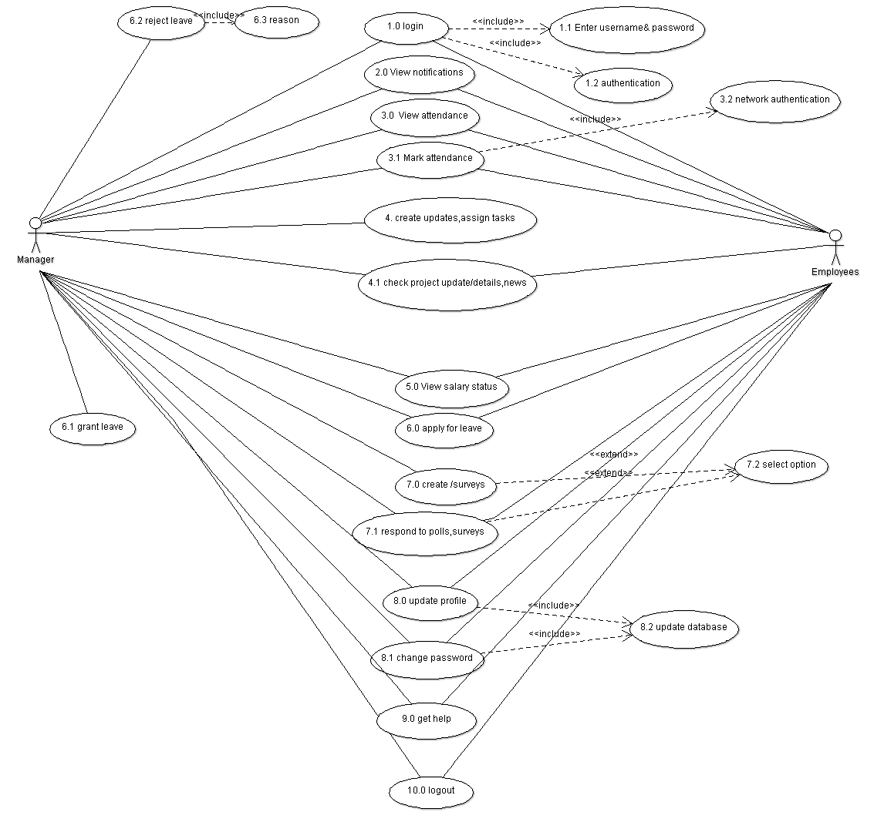

## Project Functions

*Detailed project requirements are described in this section.*

***1. Manager/Employee Login:*** *The user must login to the web application using their unique*

*user-id and passwords provide to them by the company. Upon success they will be*

*allowed to access their notifications etc. All the users would exclusively be employees of*

*the company, who is the client of this project.*

***2. Attendance:*** *The user will be able to mark his/her attendance provided he/she is logged on*

*to the application using the company's network and also within the specified time.*

***3 Salary Status:*** *The users will be able to check their salary status. Suppose, if a user has*

*taken a loan then he/she can check the interest being deducted from their salary and can*

1. *see the remaining amount which they would receive.*

***4. Leave Application:*** *The application will allow the user to apply for a leave upon which a*

*notification would be sent to the manager concerned who can either approve the leave or*

*reject it with a reason. The manager will also be able to see the number of leaves*

*as well the type of leaves the employee has taken within a given duration.*

***5. Feedback/polling/survey:*** *If the company wants to launch a new product or consider a*

*change in policies and practices it can take poll and surveys to collect its employee’s*

*feedback.*

***6. Updates about:*** *Any Events, Project updates, new employees, any changes in the*

*company.*

***7.***  *Message will be sent to the user's phone if any one tries to access their account with the*

*wrong password three times.*

## User Classes and Characteristics

The expectation of people using this software is expected to be within the organization having employee ID/number. This application would be highly useful to large organizations(with similar structure to the client)as it will facilitate easier and reliable communication with their employees.

## Operating Environment

This web application operates on a LAMP stack Standard Operating Environment in AWS(Amazon Web Services)medium instance. Entire application is hosted on a single instance. No other dependencies are present.

## Design and Implementation Constraints

NONE

## User Documentation

*The software is self-sufficient and it does not require any tutorials or any external help. But for the convenience of the user, an additional document containing the user flow(essentially an user guide) will be available in the help tab of the application.*

## Assumptions and Dependencies

**Assumptions:**

* Data transfer, synchronization/migration is out of scope of this project.
* Before starting the project, PopcornApps will give device matrix that the app should support
* PopcornApps to provide sample employee data to test the application
* PopcornApps to provide timely feedback

**Dependencies:**  
  
None

# External Interface Requirements

## User Interfaces

*This user will be simple and intuitive. However, a lot of priority has been given to avoid third party and non ingenious plugins to avoid any issues which could cause any unauthorized access or hampering of data(which is highly undesirable in any context). The work flow of the software is also in sync with the functionalities that we agreed upon. However, for any user to access the information, a login page will be in place. The software is designed so as to inform the user on his/her mobile phone via a message if the account of the specific user has been tried to access with wrong pass codes 3 times in a row.*

## Hardware Interfaces

No external or extra hardware components are required to facilitate the functionality of this application.

## Software Interfaces

*The only possible(and mandatory) way to login to the application will be the username and password (provided by the company), username will be unique for every employee. All the functions mentioned inside the software will be accessed by authorized users only. It will also be a platform independent system allowing the users with the freedom to use any machine they like without locking them to use particular platform and devices with exception of marking attendance where the user has to login to the application using the organization's network only to prevent discrepancies*.

## Communications Interfaces

Communication standards that are going to be used are FTP&HTTP. Neither data nor application encryption mechanism is required.

## System Features

USER LOGIN

|  |  |  |
| --- | --- | --- |
| **REQUIREMENT**  **IDENTIFIER** | **NAME** | **DESCRIPTION** |
| *UL_1* | *USER LOGIN-1* | *The user-id and password entered by the user will be authenticated by matching it with the database.* |
| *UL_2* | *USER LOGIN-2* | *If the entered user-id or password do not match then user will be notified to re-enter the former.* |
| *UL_3* | *USER LOGIN-3* | *If the user forgets his/her password, he/she will be required to reset it by entering his/her email-id after which he/she will receive a password reset notification on the registered email-id.* |
| *UL_4* | *USER LOGIN-4* | *If the user-id and password is successfully authenticated, the user is directed to his/her dashboard.* |

ATTENDANCE

|  |  |  |
| --- | --- | --- |
| **REQUIREMENT**  **IDENTIFIER** | **NAME** | **DESCRIPTION** |
| *AD_1* | *ATTENDANCE-1* | *On clicking the attendance button the user will be given an option to either check his attendance record or to mark his/her daily attendance.* |
| *AD_2* | *ATTENDANCE-2* | *If the user selects check attendance option, he/she will be shown the attendance record.* |
| *AD_3* | *ATTENDANCE-3* | *If the user wants to mark his/her attendance it is mandatory to login using the organization’s network. If this requirement is met the user will able to mark his/her attendance.* |
| *AD_4* | *ATTENDANCE-4* | *If the user has not logged in using the organization’s network and tries to mark his/her attendance, he/she will be shown an error display message.* |

LEAVE APPLICATION

|  |  |  |
| --- | --- | --- |
| **REQUIREMENT IDENTIFIER** | **NAME** | **DESCRIPTION** |
| *LA1* | *LEAVE APPLICATION-1* | *Apply for leave.* |
| *LA2* | *LEAVE APPLICATION-2* | *Send notification that an employee has applied for leave to the concerned manager.* |
| *LA3* | *LEAVE APPLICATION-3* | *If leave is granted notification is sent to the concerned employee.* |
| *LA4* | *LEAVE APPLICATION-4* | *The manager may choose to reject the leave application with a valid reason and notification will be sent to the employee* |

SALARY STATUS

|  |  |  |
| --- | --- | --- |
| **REQUIREMENT**  **IDENTIFIER** | **NAME** | **DESCRIPTION** |
| *SS_1* | *SALARY STATUS-1* | *If the user clicks on the salary status button, he/she will be shown his/her last months received salary. The user will also be able to see any tax/salary cuts as well as any bonuses received. User will also able to see previous salary records.* |

NOTIFICATIONS

|  |  |  |
| --- | --- | --- |
| **REQUIREMENT**  **IDENTIFIER** | **NAME** | **DESCRIPTION** |
| *N_1* | *NOTIFICATION-1* | *The user will see a notification box in the dashboard in which he/she will be able to see notifications. On clicking any of the notifications the user will be directed to the notification page where he/she will be able to see the complete message.* |
| *N_2* | *NOTIFICATION-2* | *The user will also be able to go to notifications page using a notification button.* |

NEWS_SURVEY

|  |  |  |
| --- | --- | --- |
| **REQUIREMENT**  **IDENTIFIER** | **NAME** | **DESCRIPTION** |
| *NS1* | *NEWS_SURVEY-1* | *View updates, news and events like promotions, holidays, etc.* |
| *NS2* | *NEWS_SURVEY-2* | *A user can view and may respond to the polls and survey.* |
| *NS3* | *NEWS_SURVEY-3* | *Any user who is a manager can create polls and surveys.* |
| *NS4* | *NEWS_SURVEY-4* | *Any user who is a manager can create updates and assign tasks.* |

ASSIGNED TASKS

|  |  |  |
| --- | --- | --- |
| **REQUIREMENT**  **IDENTIFIER** | **NAME** | **DESCRIPTION** |
| *AT* | *ASSIGN_TASK* | *A user who is a manager can assign tasks to certain employees upon which those employees will receive notifications.* |

SETTINGS

|  |  |  |
| --- | --- | --- |
| **REQUIREMENT IDENTIFIER** | **NAME** | **DESCRIPTION** |
| *S1* | *SETTINGS-1* | *An user can change his/her password or which the suitable notification will be sent* |
| *S2* | *SETTINGS-2* | *An user can update his/her profile for which the suitable notification will be sent* |
| *S3* | *SETTINGS-3* | *Make necessary changes in the corresponding database* |

HELP

|  |  |  |
| --- | --- | --- |
| **REQUIREMENT IDENTIFIER** | **NAME** | **DESCRIPTION** |
| *H* | *HELP* | *Contains an user guide* |

LOGOUT

|  |  |  |
| --- | --- | --- |
| **REQUIREMENT IDENTIFIER** | **NAME** | **DESCRIPTION** |
| *LO* | *LOGOUT* | *Let’s the user logout of the application and displays a thank you message along with a link for the login page* |

# Other Nonfunctional Requirements

## Performance Requirements

*There are no specific and high requirements as such, any popular and compatible operating system with a modern internet browser will be able to support this software application.*

## Safety& Security Requirements

PopcornApps company safety and security policies are followed. No additional requirements.

## Software Quality Attributes

*This a high quality software. It has been put through rigorous and a large variety of tests(in many possible environments). There are question marks on its features such as: adaptability, availability, correctness, flexibility, interoperability, maintainability, portability, reliability, reusability, robustness, testability, and usability.*

## Business Rules

This software is operated by the employees of the organization governed by the defined policies and security measures. Every individual who operates/uses this software must adhere to the company policies and security measures.

# Other Requirements

*None as such. However, it might be a good idea/ better practice to keep the browsers upgraded and updated, with use of genuine copy of the operating system and a fast internet service.*

Appendix A: Glossary

***User(s)****: An employee of the organization*

***Organization****: PopcornApps*

Appendix B: To Be Determined (TBD) List

None for now. But as the document gets updated, this section will get updated if any TBD items are found.